Eppendorf 15 Amp Centrifuge
Eppendorf 15 Amp Centrifuge Models 5810R and 5804R

Models 5810R and 5804R
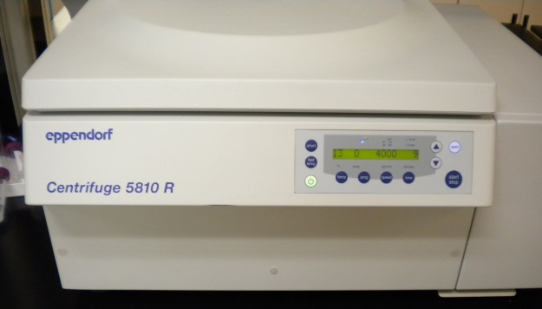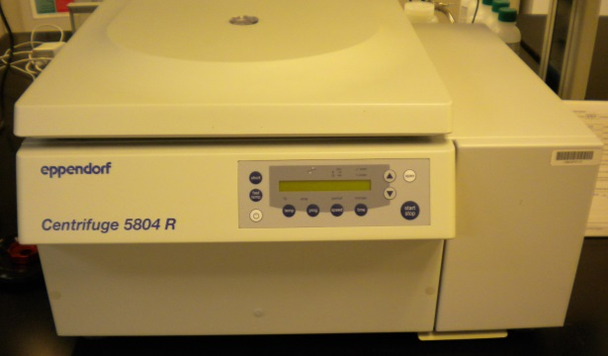
Potential Hazards while performing these activities:
Electrical Hazard | This equipment contains electrical units that may come in contact with skin or liquids.
Cut Hazard | This equipment contains moving parts with sharp edges.
Pinch Hazard | The lid of the centrifuge CLOSES AUTOMATICALLY and may pinch/crush appendages.
Chemical Hazard | Improperly sealed tubes or spilled liquids may atomize or vaporize in the chamber.
Fire Hazard | Improper use of this equipment may cause a fire hazard.

Preventions to reduce exposure to hazards:
Eye Protection | Wear safety glasses while operating.
Protective Glove | Wear appropriate gloves for heat and chemical usage.
Non-Slip, Closed Shoes | Wear non-slip, closed shoes to avoid spills.
Read Manual | Become familiar with this guide before operating.

Note:
Take care opening/closing the lid. It is heavy and may fall if not properly opened. Closing the lid may require pressing until the latch is engaged.

Setup Steps | Pictures
- Verify the device is plugged in and the Main Power switch is in the ON position. | 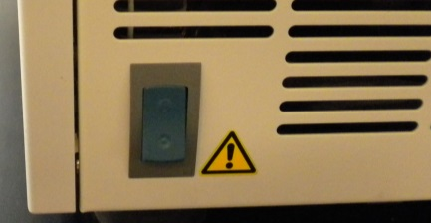
- Press the power on button located on the unit control panel. | 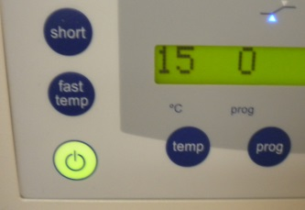
- Press the “OPEN” button on the unit control panel. | 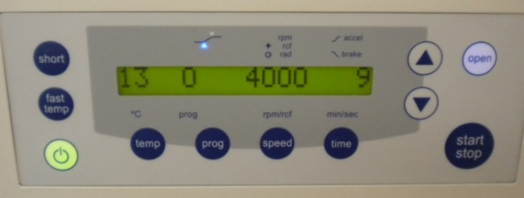
- Remove swing bucket and either fill with samples or use centrifuge bottle. | 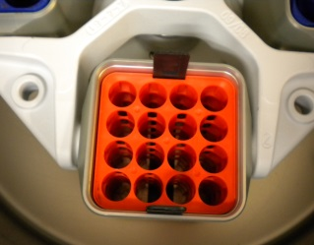
- Carefully place samples to distribute weight across entire rack. There should be even weight distributions in swing buckets across from each other. | 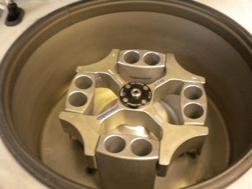
Operation | Pictures
- Place samples in bucket. THEY MUST BE COUNTERBALANCED!
- Close lid 90% closed. Lid will CLOSE AUTOMATICALLY.
- With lid CLOSED, select “TIME” or “SPEED” and use arrows to adjust. | 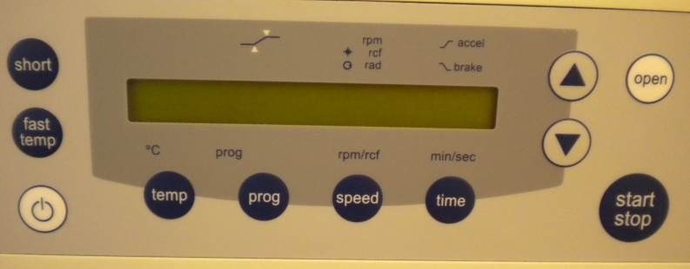
- For a soft start/stop, with lid closed, press “TIME” repeatedly.
- To turn Alarm ON/OFF, with lid closed press “TIME” and “SPEED” simultaneously.
- Once cycle is STOPPED, press “OPEN” to retrieve samples. | 