Mettler pH Meter
Mettler pH Meter

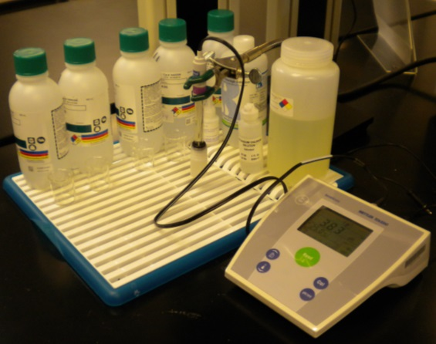
Potential Hazards while performing these activities
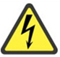 Electrical Hazard | This equipment contains electrical units that may come into contact with skin or liquids.
Chemical Hazard | This equipment is used near potentially hazardous chemicals.
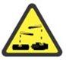 Corrosive Hazard | This equipment is used for measuring acids and bases.
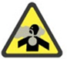 Chocking Hazard | Because liquids are agitated, dangerous fumes may be released. Use of a fume hood may be required.
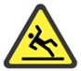 Slip Hazard | Liquids from the unit may fall on the floor, causing slippery conditions.

Preventions to reduce exposure to hazards:
Eye Protection | Wear safety glasses while operating.
Protective Gloves | Wear appropriate gloves for chemical usage.
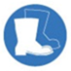  Non-Slip, Closed Shoes | Wear non-slip, closed shoes to avoid spills.
Read Manual | Become familiar with this guide before operating.

Note:
- Make sure the calibration buffer range includes the pH of the samples.
- The slope is automatically calculated after each buffer. Make sure the slope is >95%.

Setup Steps | Pictures
- Setup the base and ensure the arm is centered.
- Ensure the electrode is plugged into the socket. | 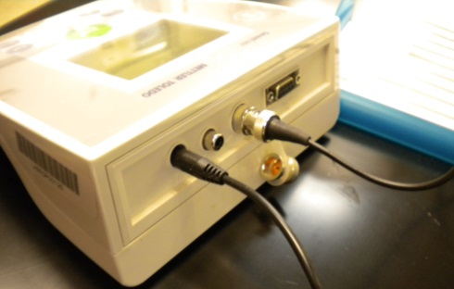
- Ensure power supply is plugged in.
- Turn the unit on. | 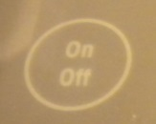
Operation | Pictures
- Decide if manual or automatic endpoints will be used. Hold READ to switch from manual endpoints to automatic endpoints and vice versa. The A =Automatic endpoint. The radical without the A =Manual endpoint. | 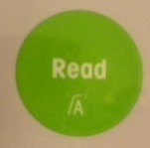  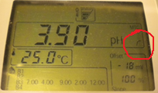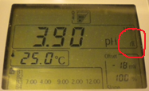
- Remove cap from electrode. | 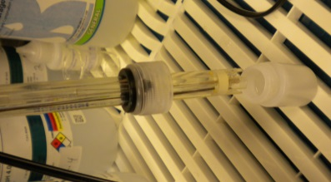
- Rinse electrode with de-ionized water.
- Place electrode in pH 7 buffer and stir. | 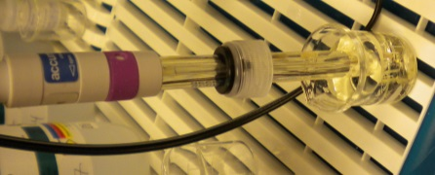
- Press Start Calibration. Wait until the screen stops blinking if using the automatic endpoint. Press READ again if using the manual endpoint. | 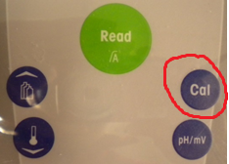
- Rinse with de-ionized water and wipe with a kim wipe. | 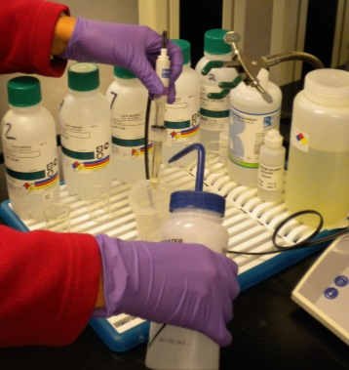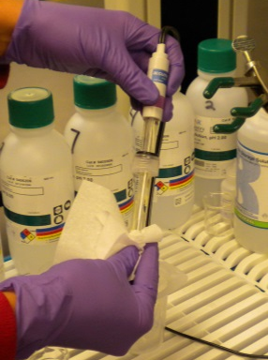
- Place electrode in the next pH buffer for calibration.
- Repeat steps 5 and 6 for a 3-point calibration.
- Make sure the slope reads 95-105%.
- Rinse with de-ionized water and wipe with a kim wipe. Place electrode in sample. The pH meter will automatically start reading the pH for the sample after the 3-point calibration so work quickly. Press Read for manual mode.
- When finished, remove and rinse electrode with de-ionized water. Place electrode back into the filling solution and recap. | 