Air Forced Gravity Oven
Gravity Oven

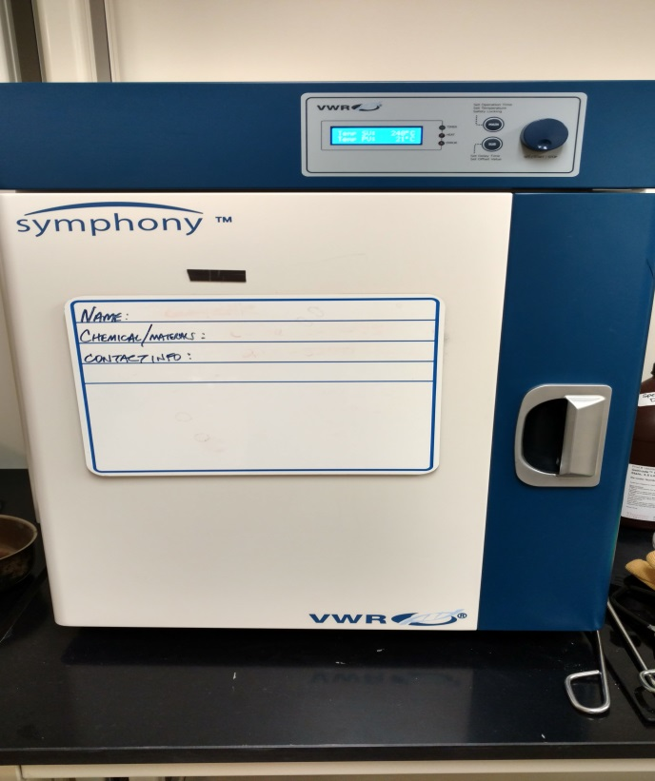
Potential Hazards while performing these activities:
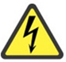 Electrical Hazard | This equipment contains electrical units that may come in contact with skin or liquids.
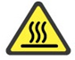 Heat Hazard | This unit produces heat which creates a hazard if improperly operated.
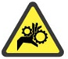 Pinch Hazard | This equipment has a door which may pinch body parts or clothing.
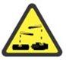 Chemical Hazard | Because chemicals are being placed in this unit, chemical hazards are present.
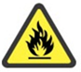 Fire Hazard | Any improper use of this equipment may cause a fire hazard.

Preventions to reduce exposure to hazards:
Eye Protection | Wear safety glasses while operating.
Protective Gloves | Wear appropriate gloves for heat and chemical usage.
Non-Slip, Closed Shoes | Wear non-slip, closed shoes to avoid spills.

Note:
DO NOT place sealed or full samples within unit. DO NOT place explosive, combustible, or flammable materials inside.

Setup and Operation Steps | Pictures
- Ensure oven is plugged in and on a stable surface. | 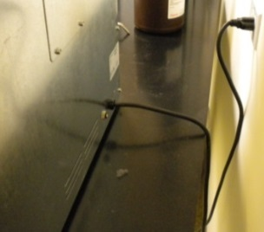
- Turn the main power switch on.
- Turn the OPT or Over Temperature Control CLOCKWISE to 30 degrees higher than the operating temperature you have chosen. | 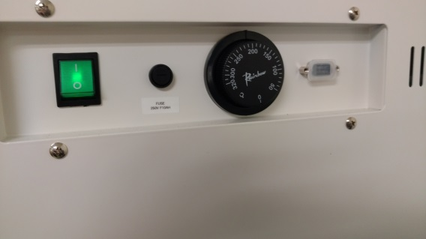
- Push the MAIN button and the SV and PV temperature will display. SV= Set Temperature  PV= Present Temperature | 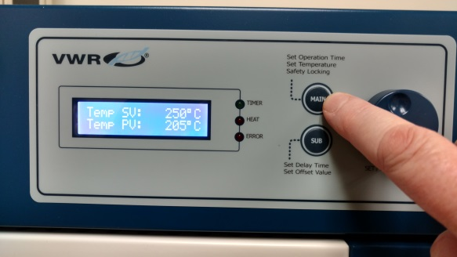
- Turn dial to desired temperature and push button to set. To STOP the heating push the button again. | 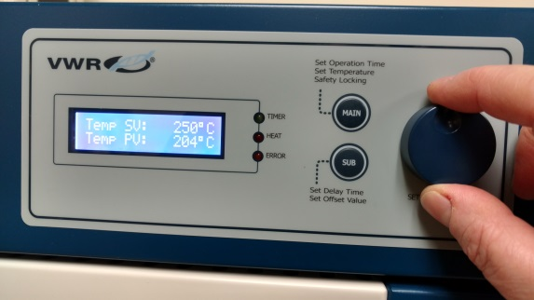
- To set timer press the MAIN button again until the TIM SV and TIM PV display. Turn the dial to the desired amount of time and push button. When timer is finished an alarm will sound. | 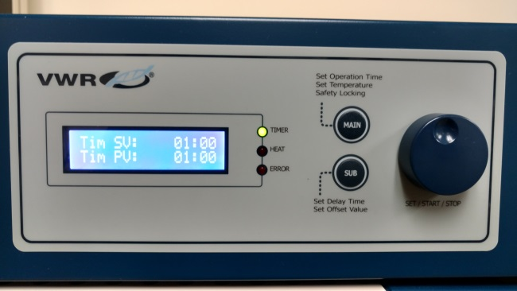
- Place samples inside of unit. UNIT WILL BE HOT! Please wear appropriate PPE. Heat resistant gloves are available in the lab. | 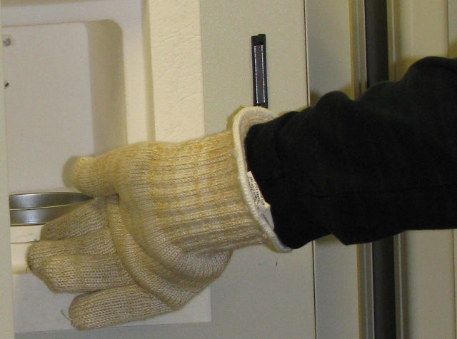
- When your samples have been removed and you are finished. Please turn off the unit. | 