Cuvette Cell Washer 0023-4061
Cuvette Cell Washer

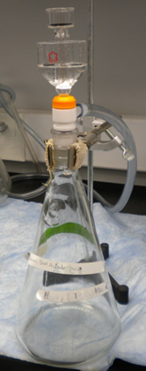
Potential Hazards while performing these activities:
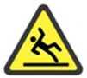  Slip Hazard | Spilled liquids may cause slip hazard.
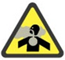  Fume Hazard | Some solvents used for cleaning cells may generate harmful fumes.
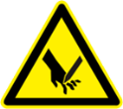  Sharps Hazard | Some materials being cleaned with this device may create a sharp hazard if broken.
Chemical Exposure Hazard | Splashing in the eyes or on the skin may occur when using this device.

Preventions to reduce exposure to hazards:
Eye Protection | Wear safety glasses while operating.
Protective Gloves | Wear appropriate gloves for chemical usage.
Non-Slip, Closed Shoes | Wear non-slip, closed shoes to avoid spills.
Good Ventilation | This activity may require use of a hood if the solvent generates harmful fumes.
Read Manual | Become familiar with this guide before operating.

Note:
- The device materials are resistant to a broad range of chemicals. Use water before trying more aggressive cleaning agents.
- Do not mix incompatible materials in the flask.
- Keep the cell upright when cleaning, otherwise, the neck of the cell might be broken.
- If the cell gets sucked down by the vacuum, remove the funnel to release the vacuum from the cell and then remove the cell.
Setup Steps | Pictures
- Ensure a vacuum source tube is connected to the arm on the flask. | 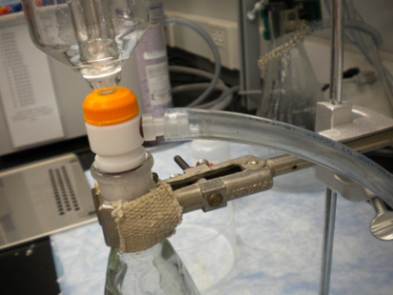
- Install the upper funnel assembly to the flask taking care to firmly seat the seal in the mouth of the flask. | 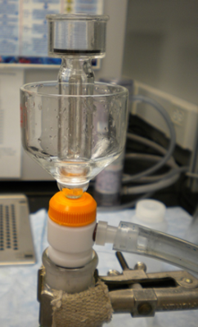
- Prepare or acquire a desired cleaning solution to be used for the items to be washed.
Operation | Pictures
- Activate the vacuum source by turning the pump on.
- Place the item to be washed inverted over the center of the platform. | 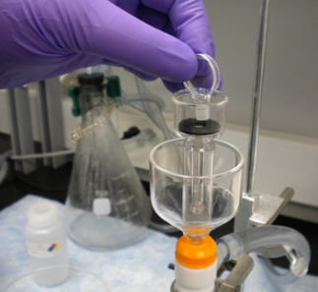
- Apply a slight downward pressure on the vessel to form a vacuum in the cell.
- Add cleaning solution to the reservoir until no residue is attached to the cell. | 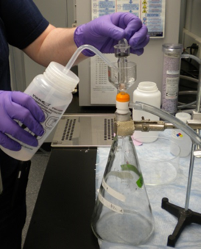
- Once the flush is complete, repeat twice using roughly 10mL of solvent per rinse. (Ethanol is recommended).
- Maintain slight downward pressure to quickly dry the vessel.
- Place rinse solution into an appropriate container and label contents.

